Mobile Web Development

Model Document

Prepared By: Eimear Horgan
Student No: 00037613
Email: Eimear.Horgan@sunlife.com
Mob: 087 6601173

Table of Contents

Section | Description | Page
1 | Wireframes | 3-5
2 | Use Cases | 6
3 | Use Case Diagram 1 – Home Screen | 7
4 | Use Case Diagram 2 – Team Screen | 7
5 | Use Case Diagram 3 – Fixtures Screen | 8
6 | Use Case Diagram 4 – Table Screen | 8
7 | Use Case Diagram 5 – More Screen | 9
8 | Use Case Diagram 6 – Full App | 10

- Wireframes
1.1 - Home Screen

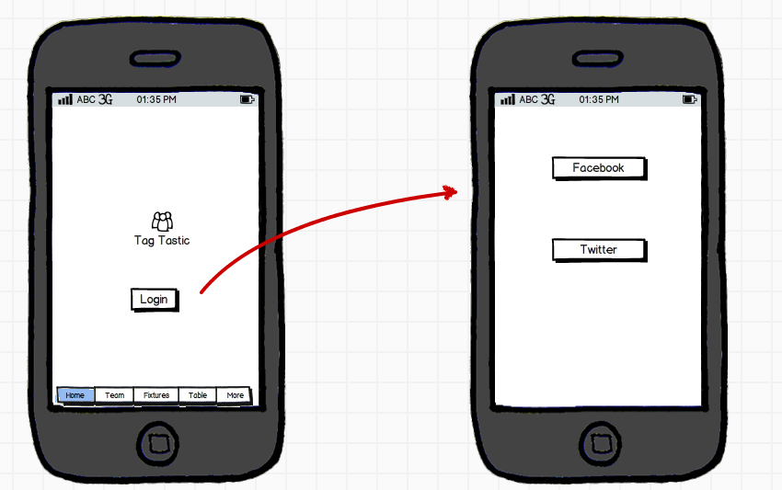

1.2 - Team Screen

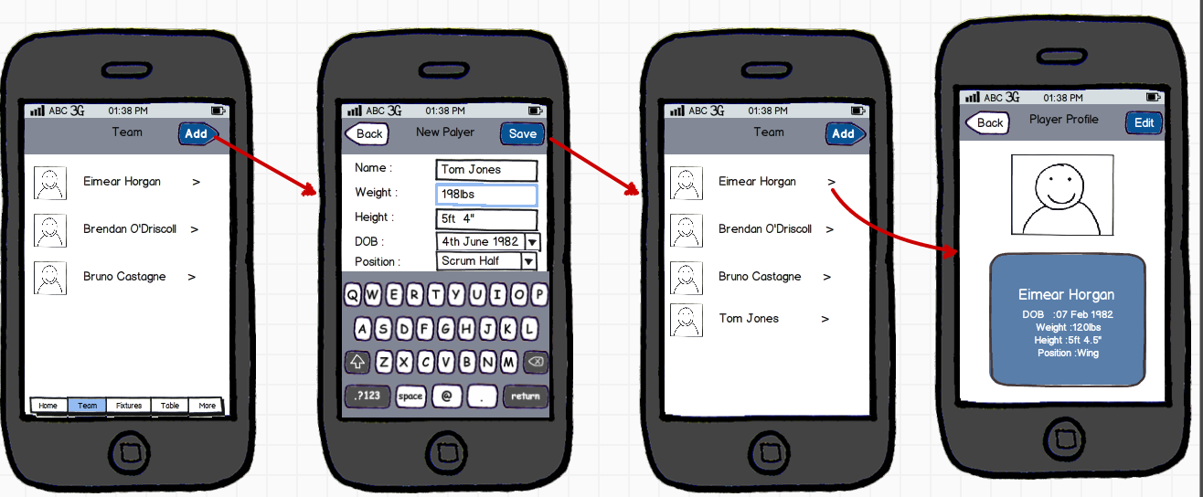

1.3 - Fixtures

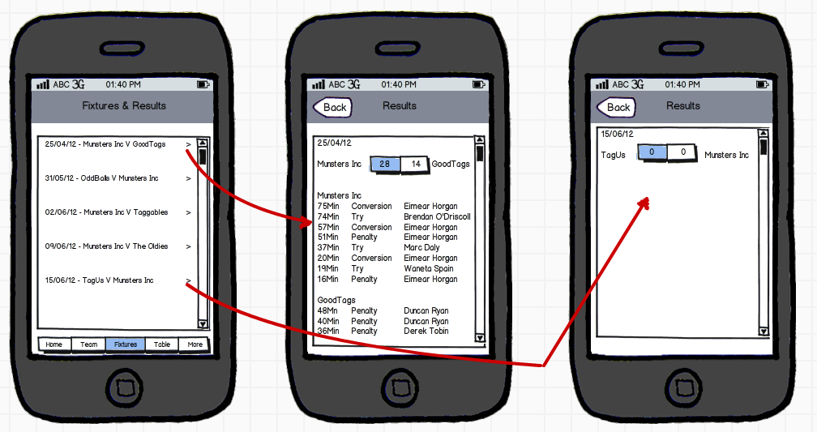

1.4 - Table
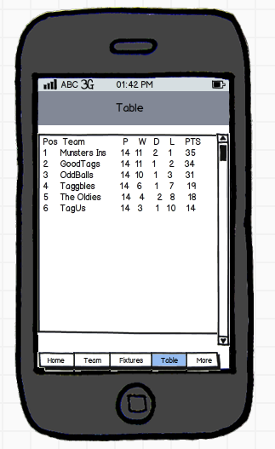
1.5 - More

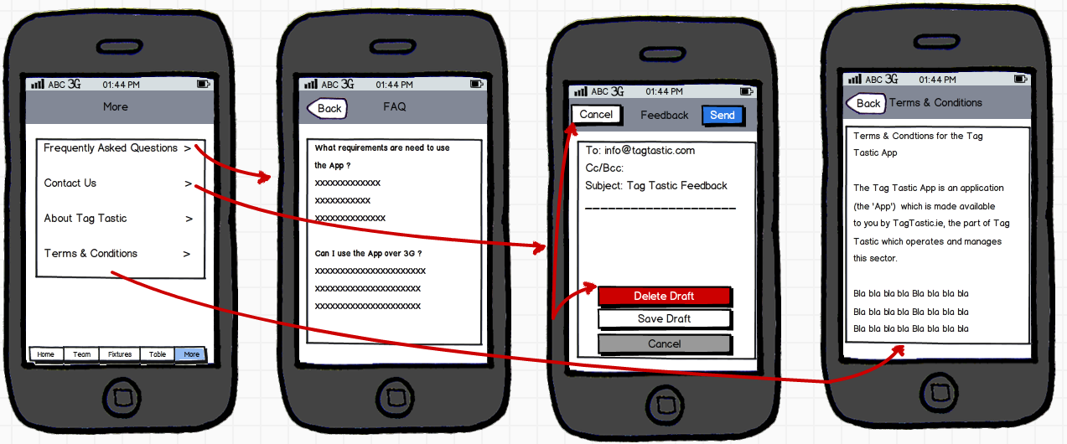

- Use Cases

Use Case ID | Use Case Name | Use Case Description
US1 | Login/Home Screen | A User can log in using either their Facebook or Twitter username and password
US2 | Logout | A User clicks logout to leave the Tag Tastic App
US3 | Team | A User can see team players, add team players, view team players details & edit details
US4 | Fixtures | A User can see Fixtures, click to see Results & see who scored the points
US5 | Table | A User see the league Table
US6 | More | A User can Read FAQ, Contact Us, Read About Tag Tastic & Read Terms & Conditions

- Use Case Diagram 1 – Home Screen

Facebook Login

Twitter Login
Non-logged in User

- Use Case Diagram 2 – Team Screen

View List of Team Players
Add A Team Player

View Team Players Profile
Logged in user

Delete Player

Edit Team Players Profile

- Use Case Diagram 3 – Fixtures Screen

View Fixtures
View Results & Scorers

Logged in user

- Use Case Diagram 4 – Table Screen

View League Table

Logged in user

- Use Case Diagram 5 – More Screen

View FAQ

Give Feedback

About Tag Tastic Tastic
Logged in user

Terms & Conditions

- Use Case Diagram 6 – Full App

Add A Team Player
Facebook Login
View List of Team Players

Twitter Login

Non-logged in User
View Team Players Profile

Delete Player

Edit Team Players Profile
View Fixtures

Logged In User
View Results & Scorers

View League Table

View More
View FAQ

Give Feedback

About Tag Tastic Tastic
Terms & Conditions

